**Introduction to AI Robotics**

**Name: Girish S Roll No: AM.EN.U4AIE22044**

# Labsheet – 4

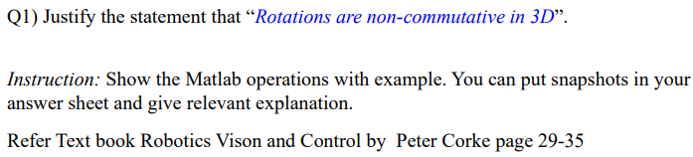

Rx = rotx(90, 'deg');

Ry = roty(90, 'deg');

R1 = Ry * Rx;

R2 = Rx * Ry;

disp('Rotation matrix R1 = Rx and Ry:');

disp(R1);

disp('Rotation matrix R2 = Ry and Rx:');

disp(R2);

isEqual = isequal(round(R1, 10), round(R2, 10));

disp('Are the rotation matrices equal?');

disp(isEqual);

figure;

subplot(1,2,1);

trplot(R1, 'frame', 'R1', 'color', 'r');

title('Rotation: Ry * Rx');

view(45, 30);

subplot(1,2,2);

trplot(R2, 'frame', 'R2', 'color', 'b');

title('Rotation: Rx * Ry');

view(45, 30);

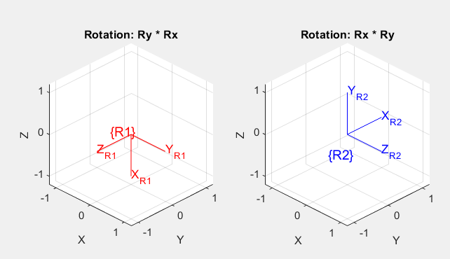

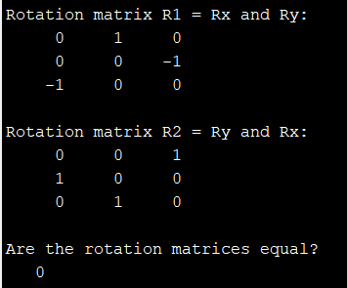

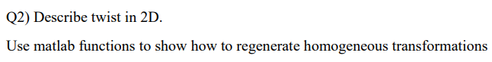

A Twist is a 6-vector consisting of a 3-vector expressing the angular velocity and a 3-vector expressing the linear velocity. Both of these are written in coordinates of the same frame, and the linear velocity refers to the linear velocity of a point at the origin of that frame. Both the body twist and the spatial twist represent the same motion, just in different coordinate frames. The body twist is not affected by the choice of the space frame, and the spatial twist is not affected by the choice of the body frame.

R = transl2(2,5) * trot2(90,"deg");

disp('Homogenous Transformation Matrix');

disp(R);

t=Twist(R);

disp(t);

disp('Twist Vector in 2D (3x1) [for 3D the twist vector is 6x1]');

disp(t.S);

disp('Twist Vector converted to Rotation Matrix');

disp(t.T);

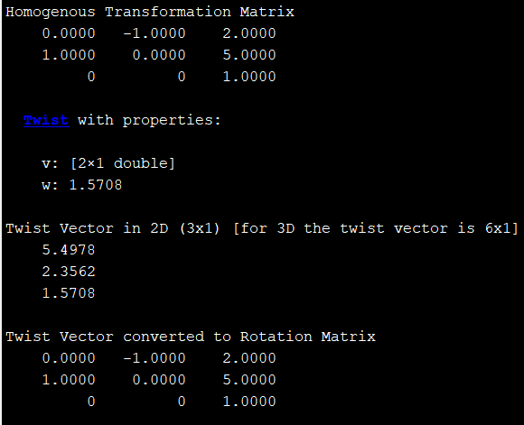

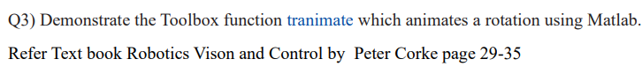

T0 = eye(4);

T1 = trotz(90);

figure;

axis([-1 1 -1 1 -1 1]);

view(3);

tranimate(T0, T1, 'frames', 50, 'rgb');

